Implementation (Validation)

1. Employee Validation
Validation is implemented using Bean Validation (JSR-380) in the Employee entity. These validations ensure that invalid employee data is not stored in the database.

File
Employee.java

Name Validation
@NotBlank(message = "Name is required")
@Column(nullable = false)
private String name;
Description
- Employee name cannot be empty.
- Database column cannot be null.
Screenshot: (Insert Employee.java – Name Validation)

Email Validation
@Email(message = "Invalid Email")
@NotBlank(message = "Email is required")
@Column(nullable = false, unique = true)
private String email;
Description
- Email is mandatory.
- Email must be in a valid format.
- Duplicate email addresses are not allowed.

Department Validation
@NotBlank(message = "Department is required")
@Column(nullable = false)
private String department;
Description
- Department field cannot be empty.

Salary Validation
@NotNull(message = "Salary is required")
@Positive(message = "Salary should be greater than zero")
@Column(nullable = false)
private Double salary;
Description
- Salary is mandatory.
- Salary must be greater than zero.
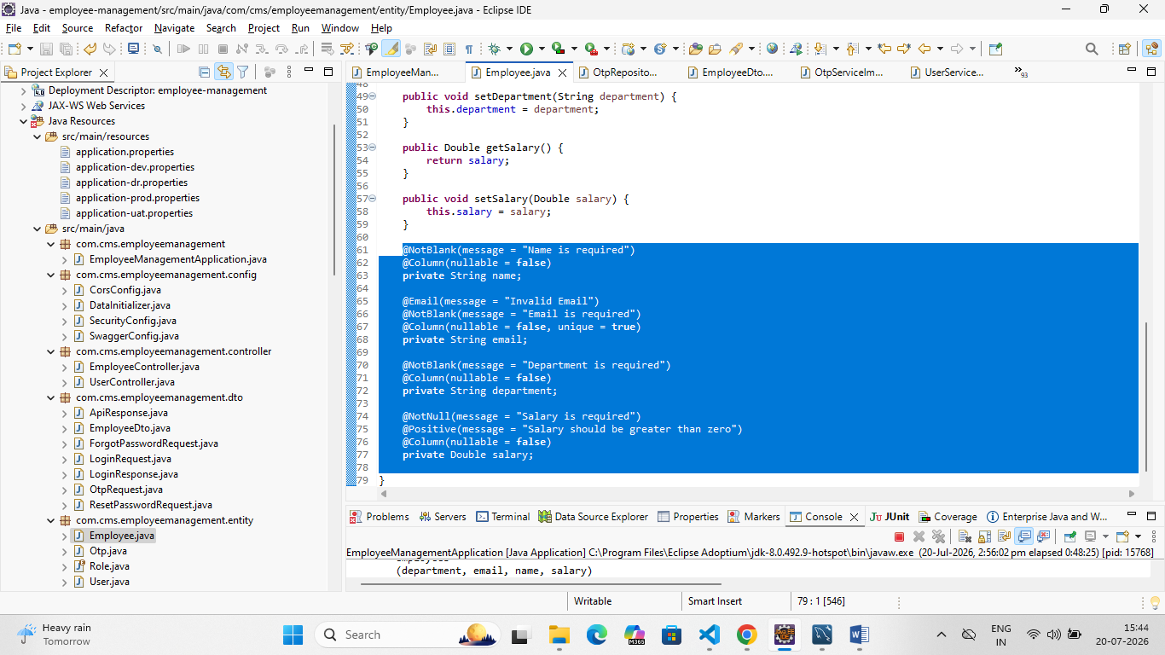

2. Controller Validation
The controller validates incoming requests using the @Valid annotation before invoking the service layer.

File
EmployeeController.java
@PostMapping
public ResponseEntity<Employee> saveEmployee(
@Valid @RequestBody EmployeeDto employeeDto) {

return ResponseEntity.ok(
employeeService.saveEmployee(employeeDto));
}
Description
- Validates employee details before saving.
- Prevents invalid request data.
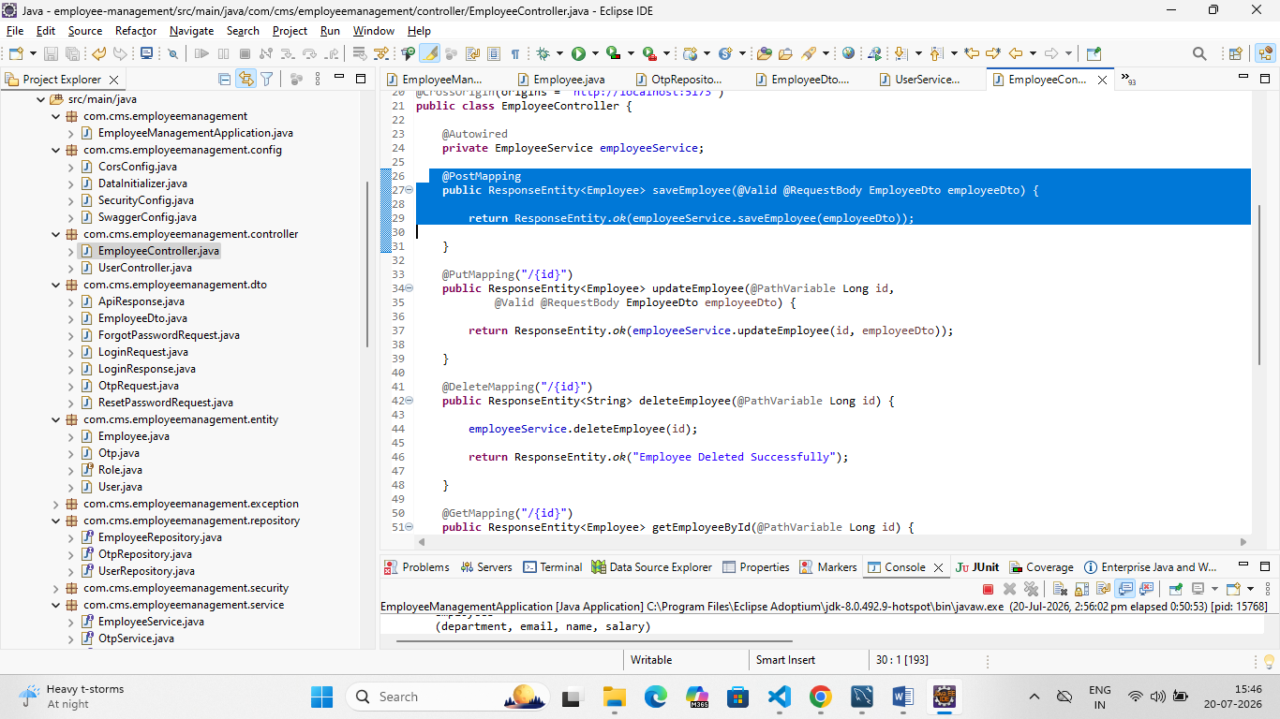

Update Validation
@PutMapping("/{id}")
public ResponseEntity<Employee> updateEmployee(
@PathVariable Long id,
@Valid @RequestBody EmployeeDto employeeDto) {

return ResponseEntity.ok(
employeeService.updateEmployee(id, employeeDto));
}
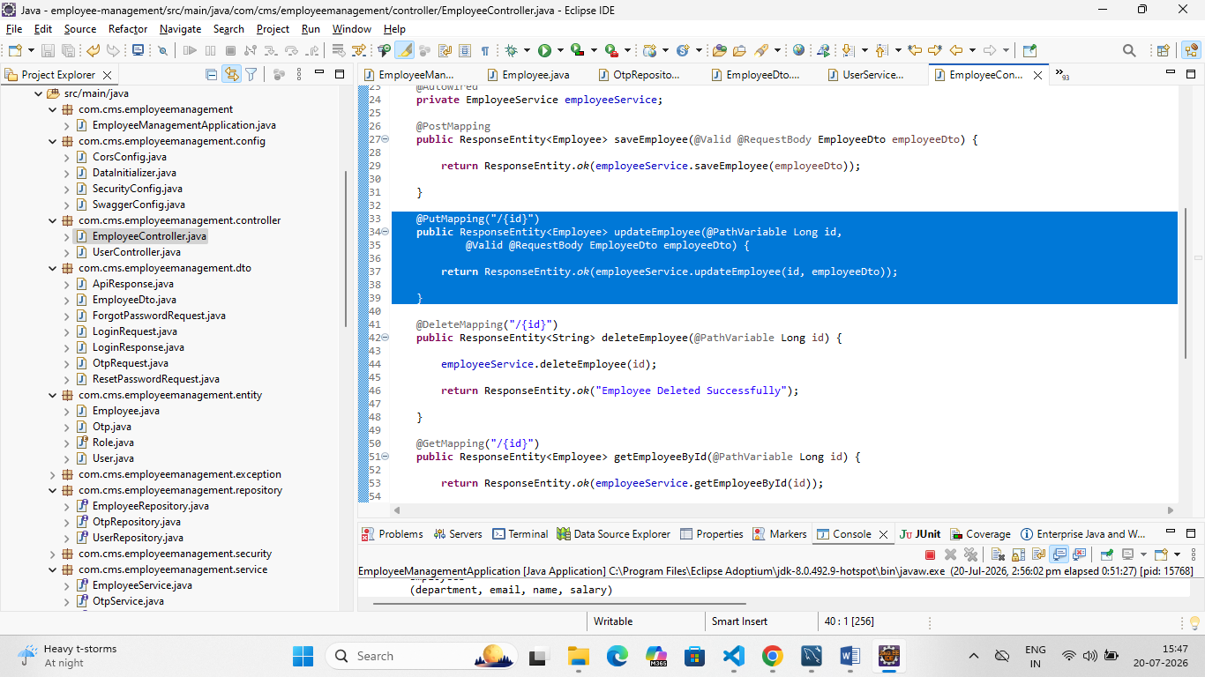

3. Login Validation

File
UserServiceImpl.java
if (!optionalUser.isPresent()) {
throw new RuntimeException("Invalid Email");
}

if (!user.getPassword().equals(request.getPassword())) {
throw new RuntimeException("Invalid Password");
}
Description
- Checks whether the email exists.
- Verifies the password before generating the OTP.
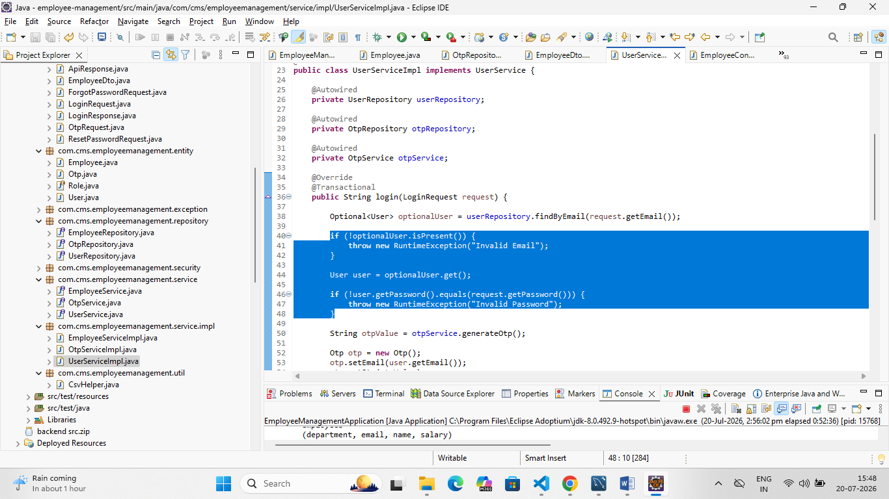

4. OTP Validation

File
OtpServiceImpl.java
if (!dbOtp.getOtp().equals(otp)) {
return false;
}

if (dbOtp.getExpiryTime().isBefore(LocalDateTime.now())) {
return false;
}
Description
- Validates the entered OTP.
- Rejects expired OTPs.
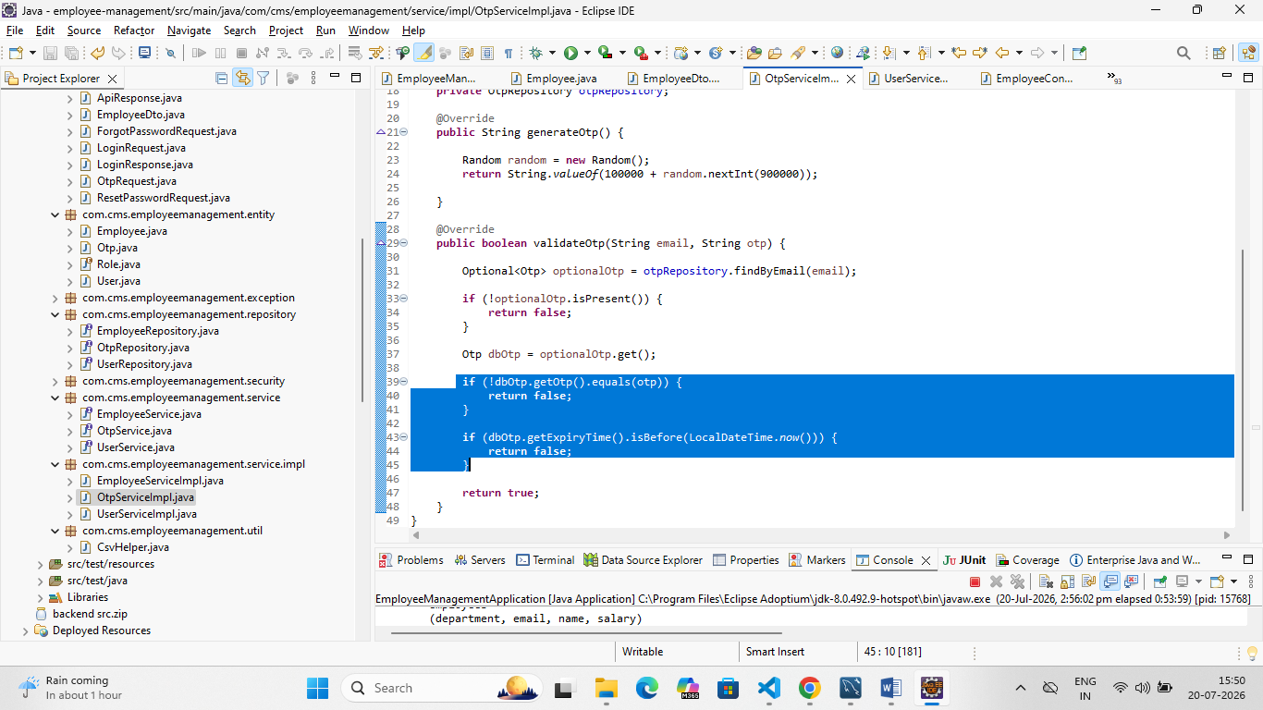

Validation Summary
Validation | Implemented
Name Required | ✔
Email Required | ✔
Email Format | ✔
Duplicate Email | ✔
Department Required | ✔
Salary Required | ✔
Positive Salary | ✔
Controller @Valid | ✔
Login Validation | ✔
OTP Validation | ✔

